**Student Debate Event Registration**

Logging in as ADMIN [Add, Update, Delete, View]:

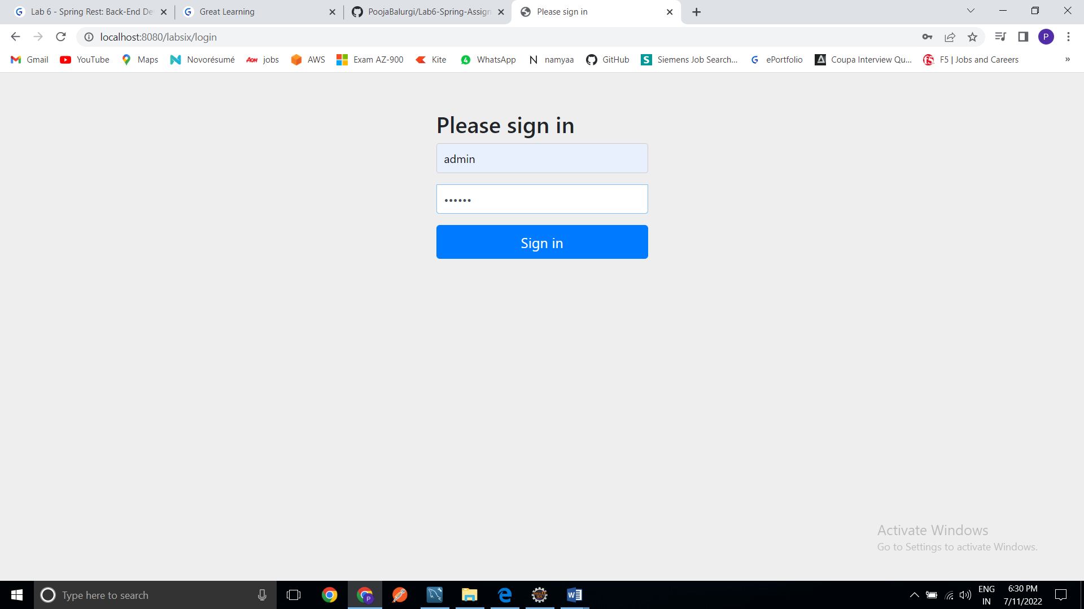

Main page: as a ADMIN

Showing list of all students.

Click on Add a new student to save new student’s information in database.

Click on Update to update that particular student information in database.

Click on Delete to delete that particular student information from database.

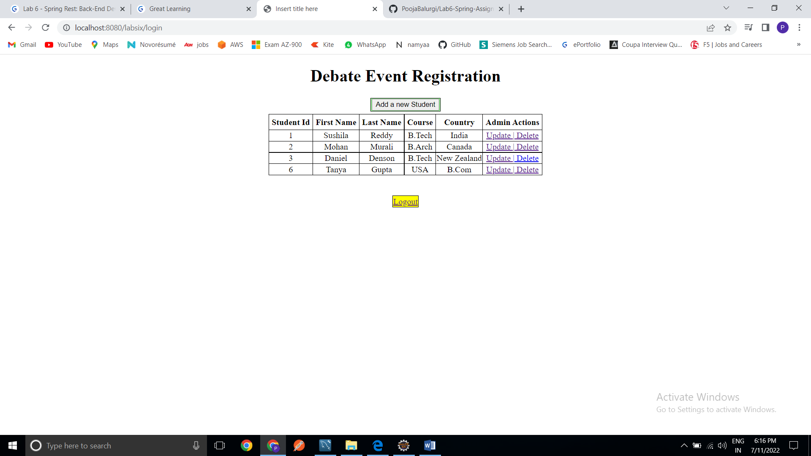

Add a new student: Adding new student “Sita Das”.

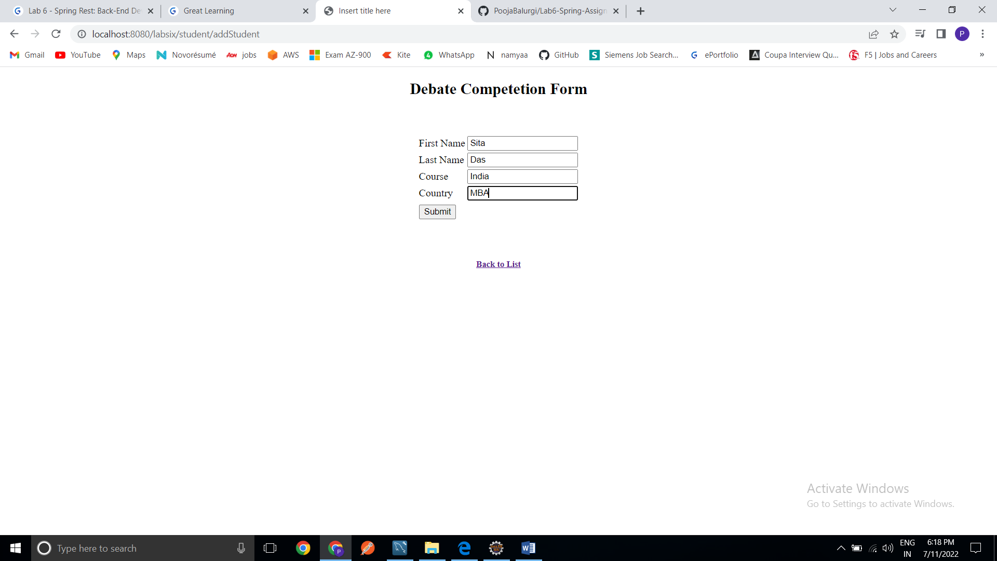

Added Sita Das:

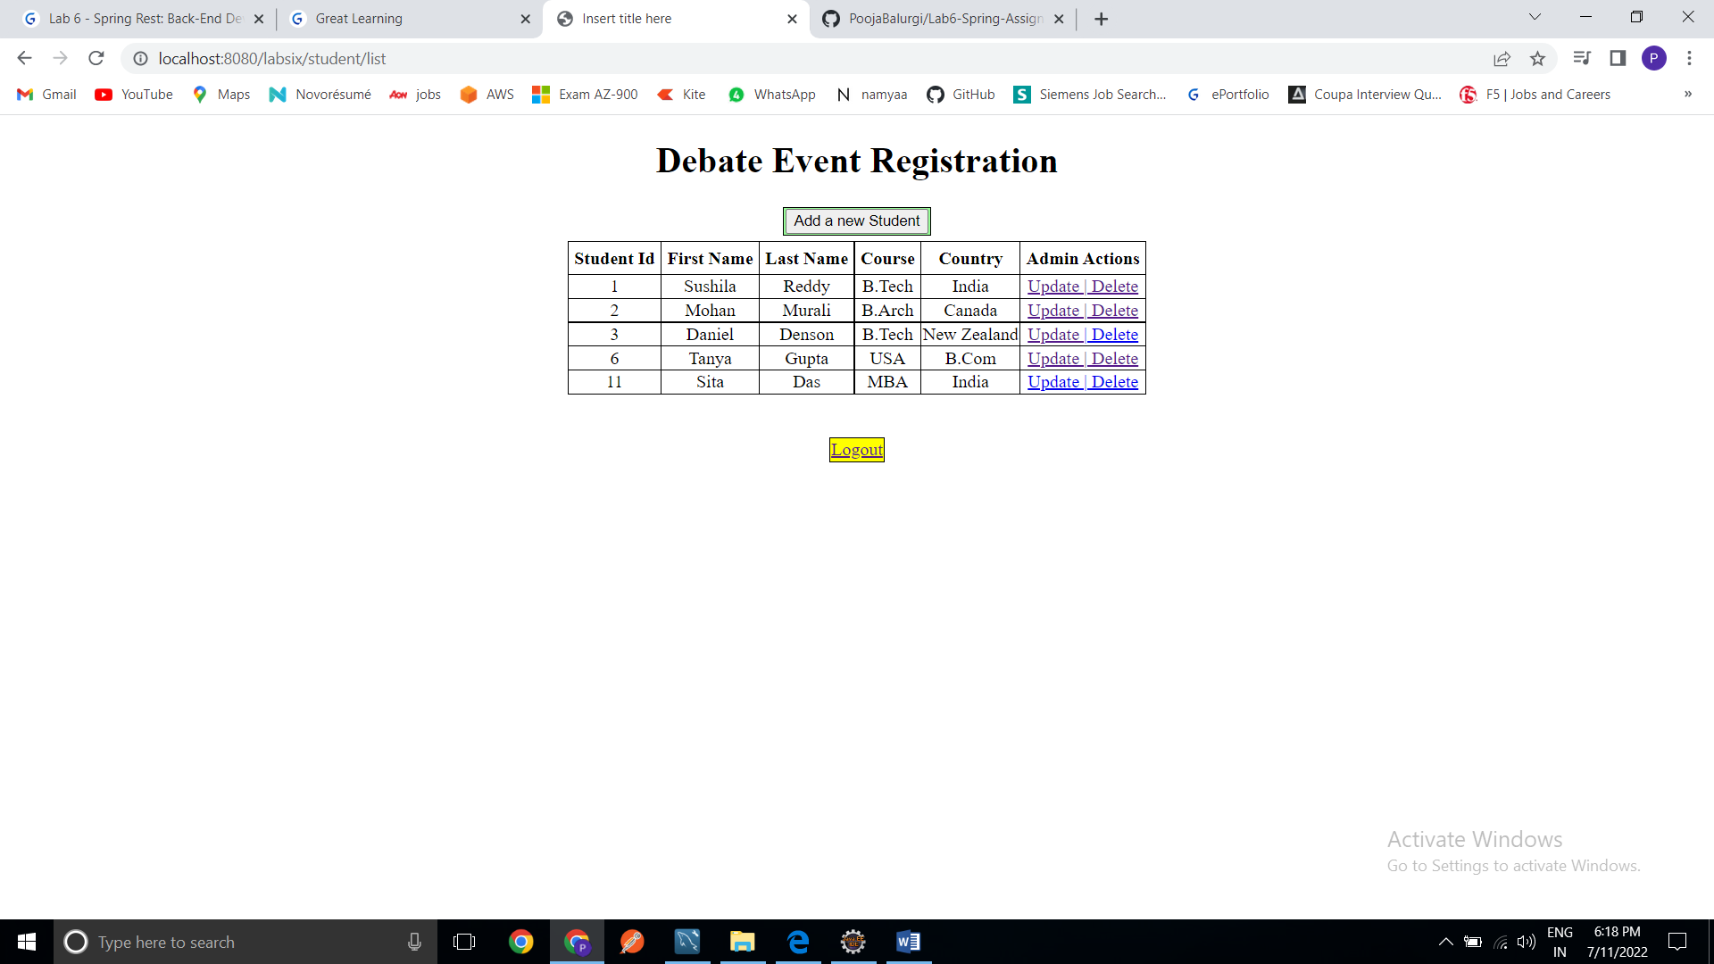

Update: Updating Sita’s course

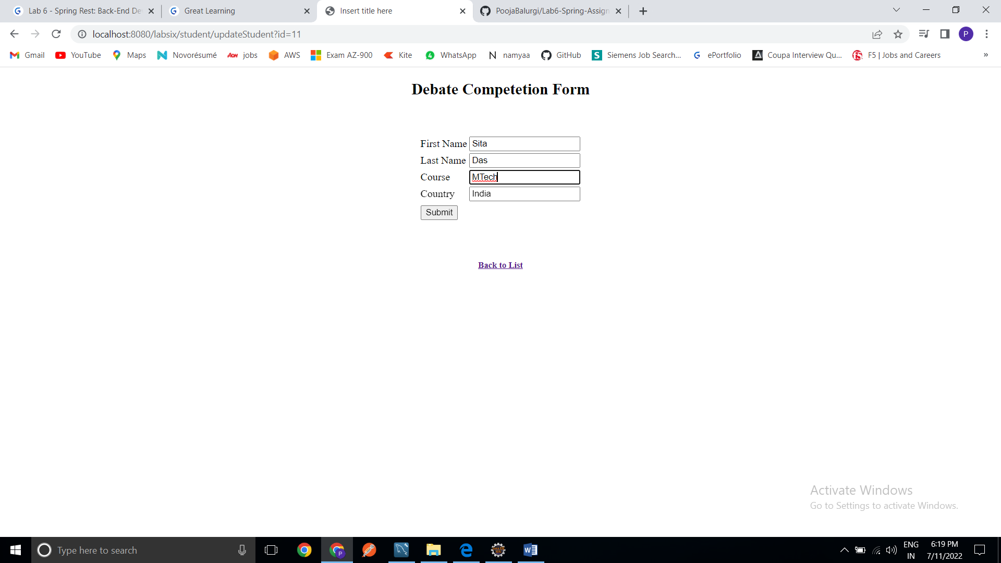

Updated:

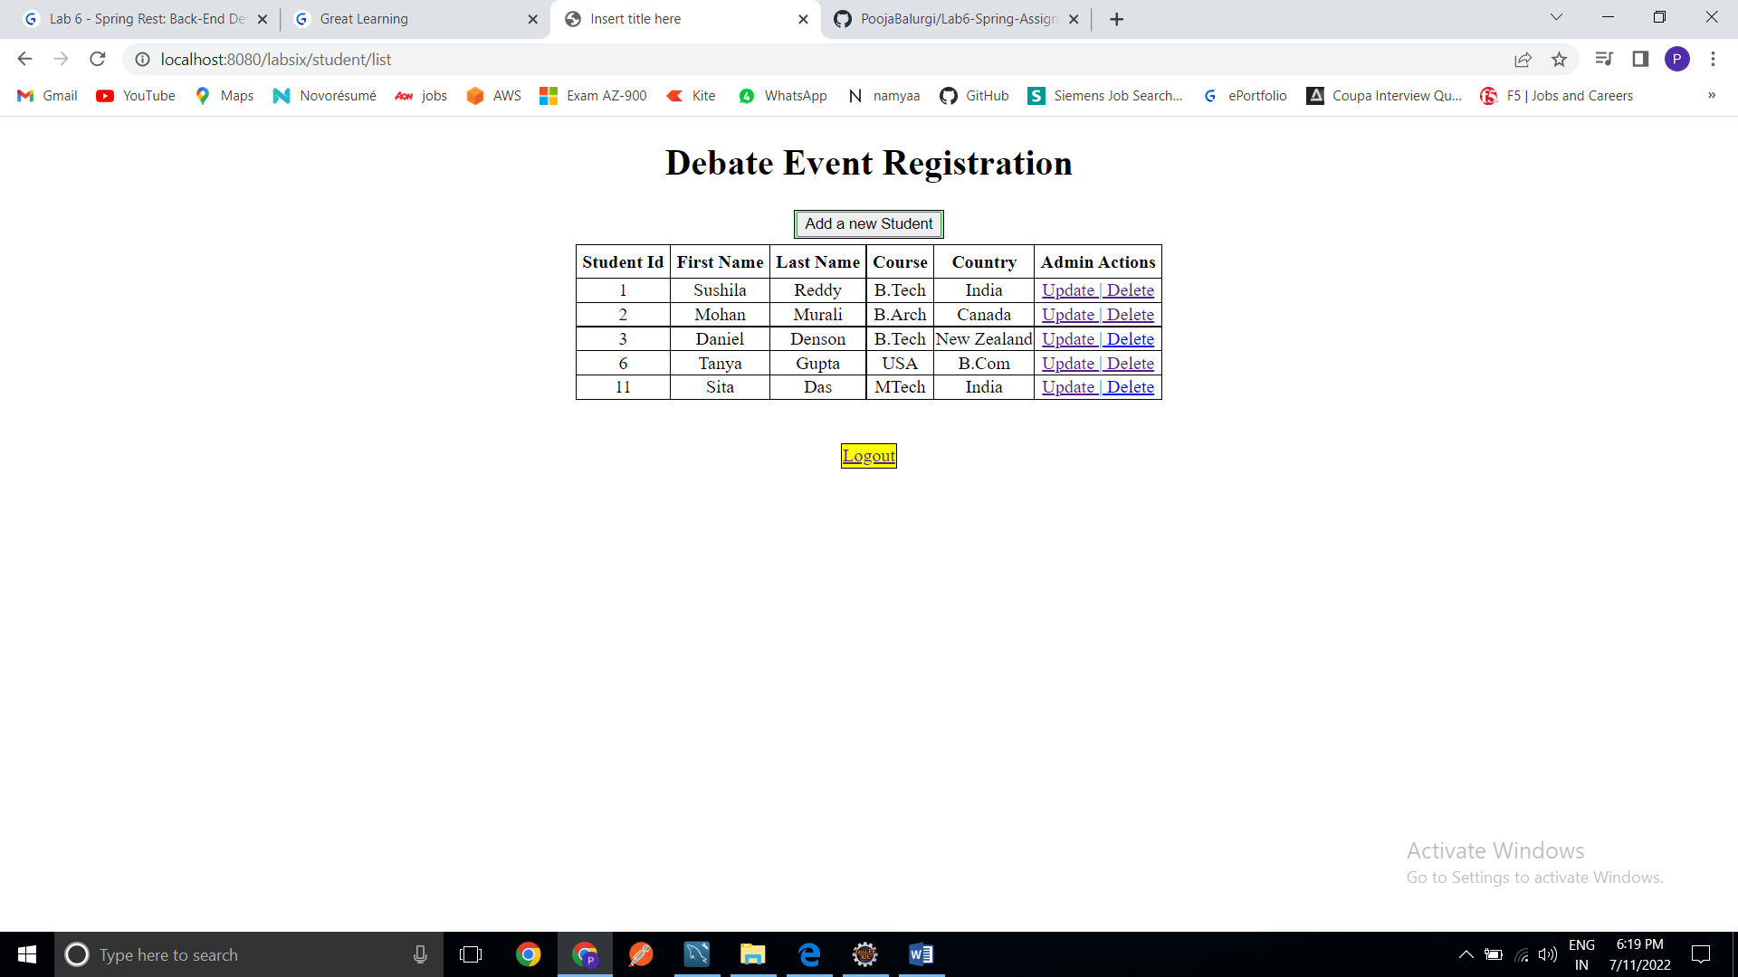

Delete: Deleting Tanya Gupta

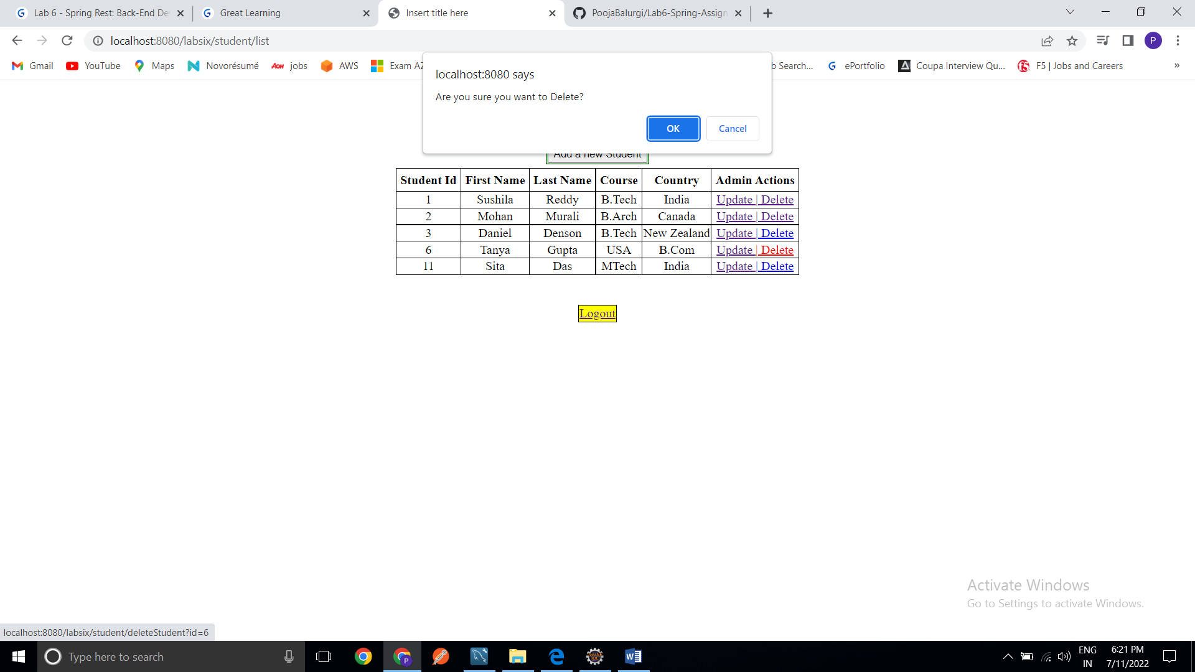

Deleted:

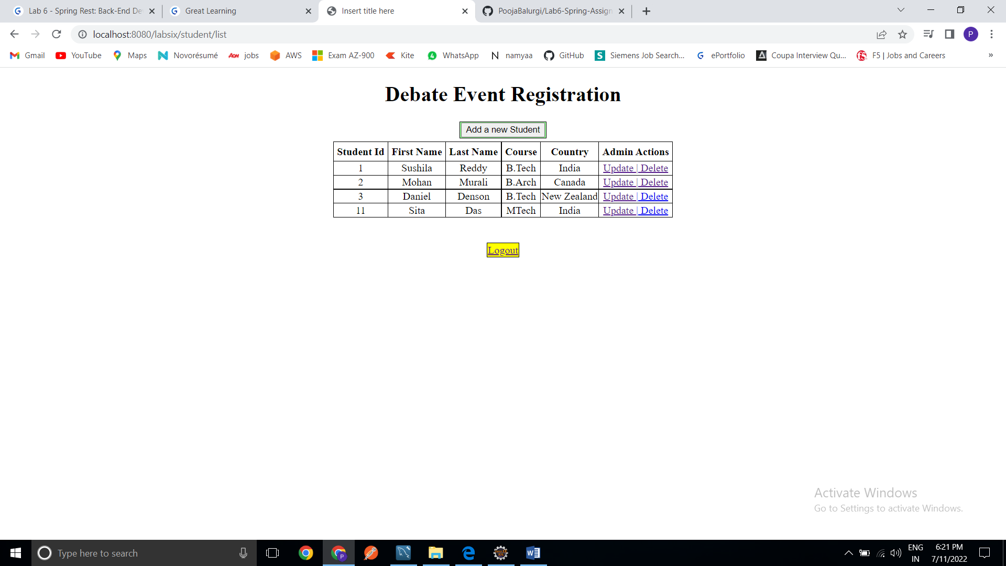

Logging in as USER [Add, View]:

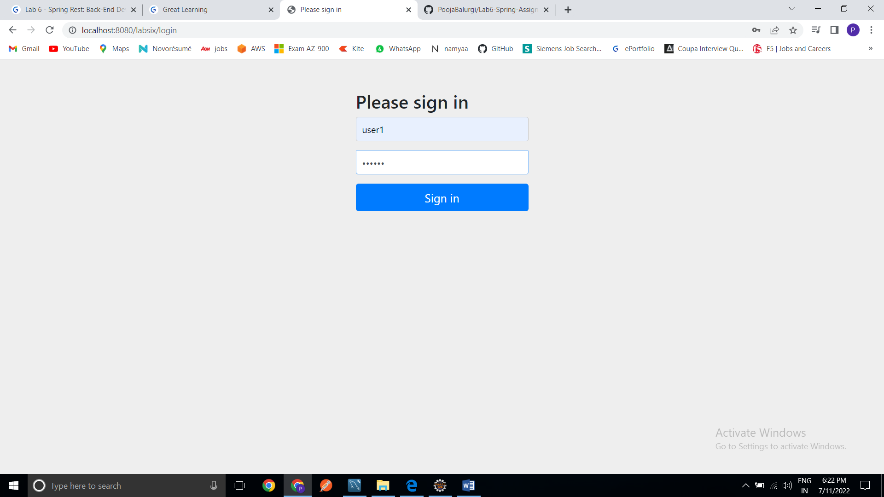

Main page: As a USER

Showing list of all students.

Click on Add a new student to save new student’s information in database.

USER cannot Update and Delete any student details. It will give error message as “Hi <name> you are not allowed to access this page.”

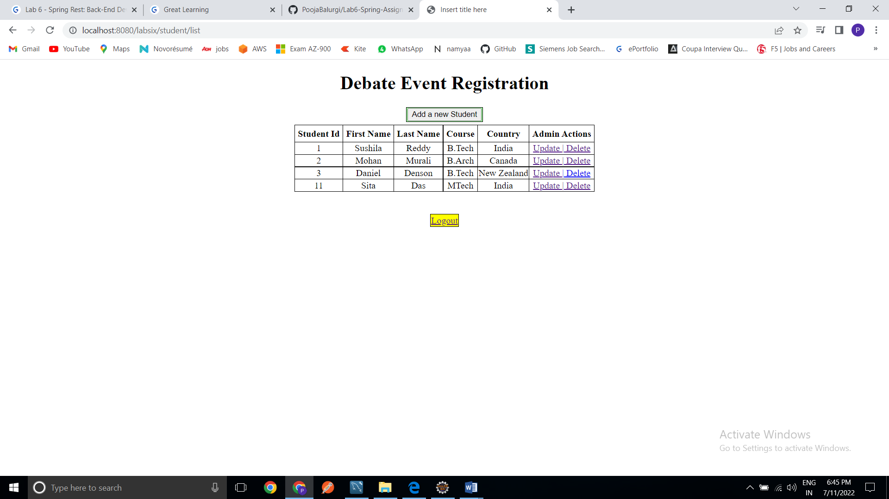

Add a new student: Adding Tanya Gupta

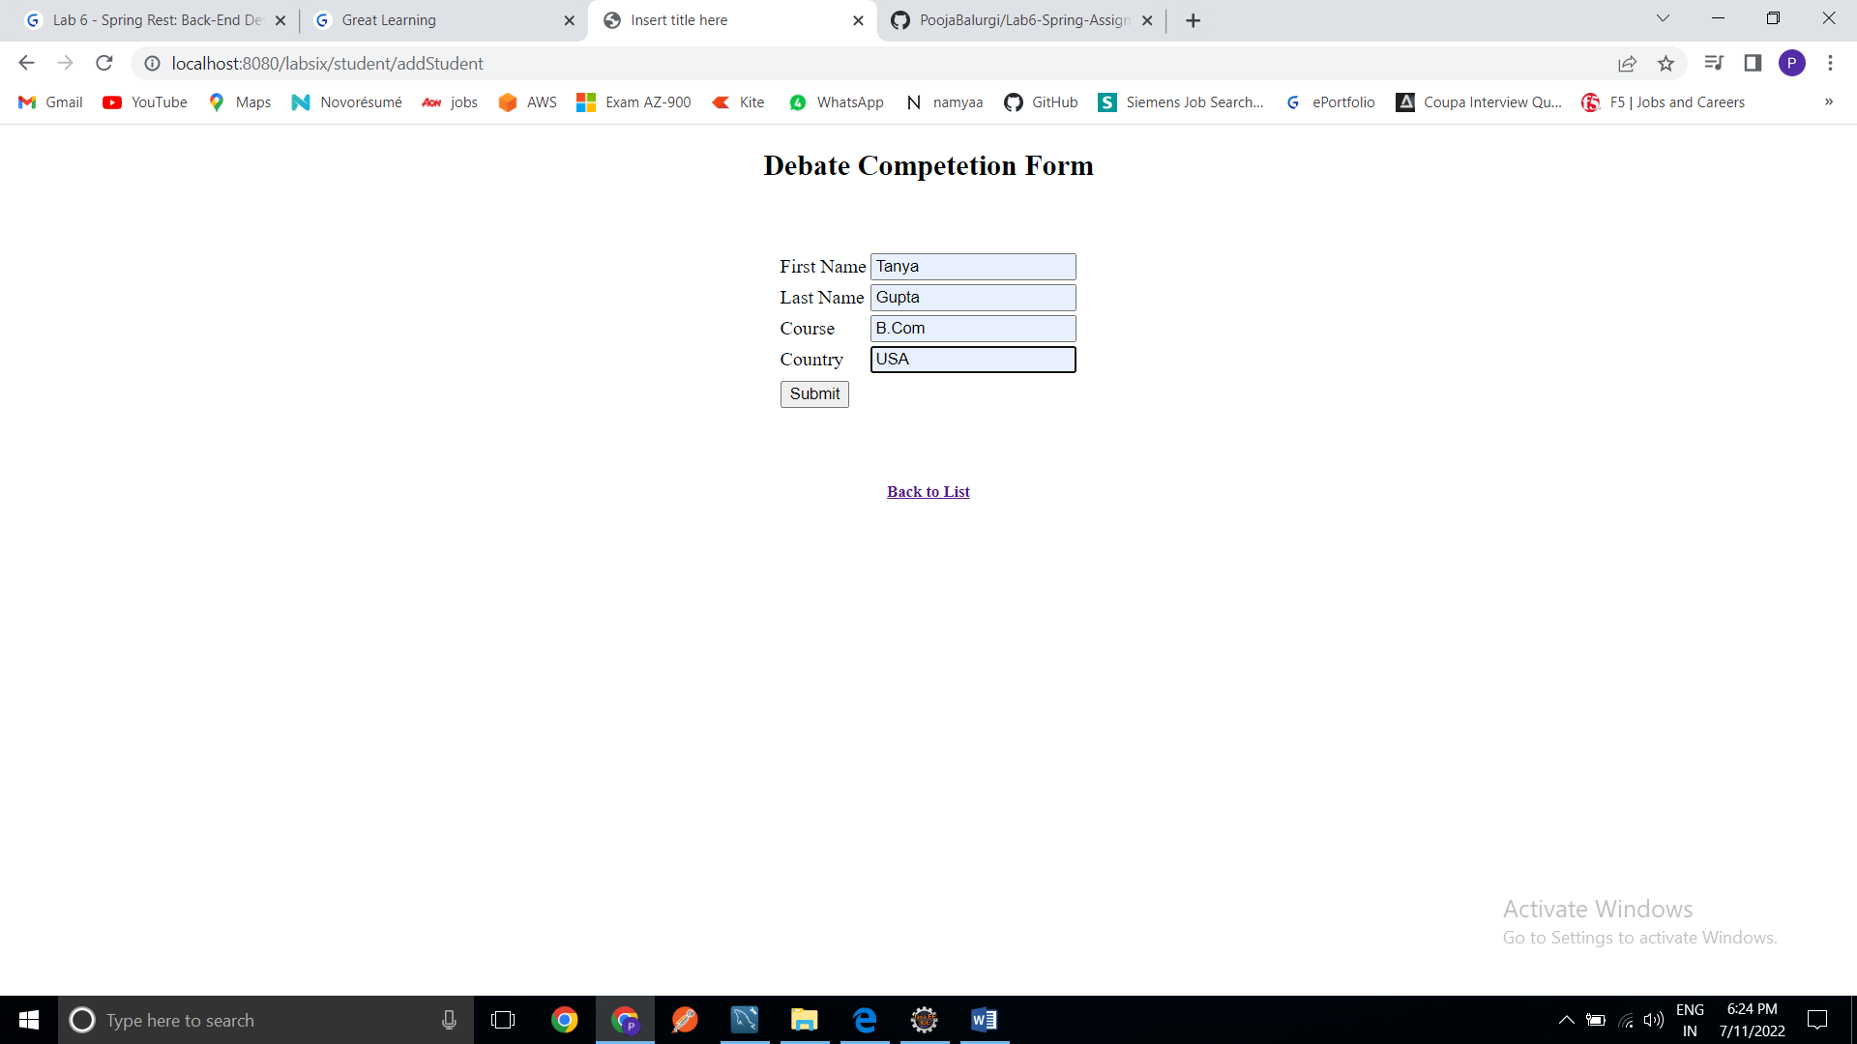

Added:

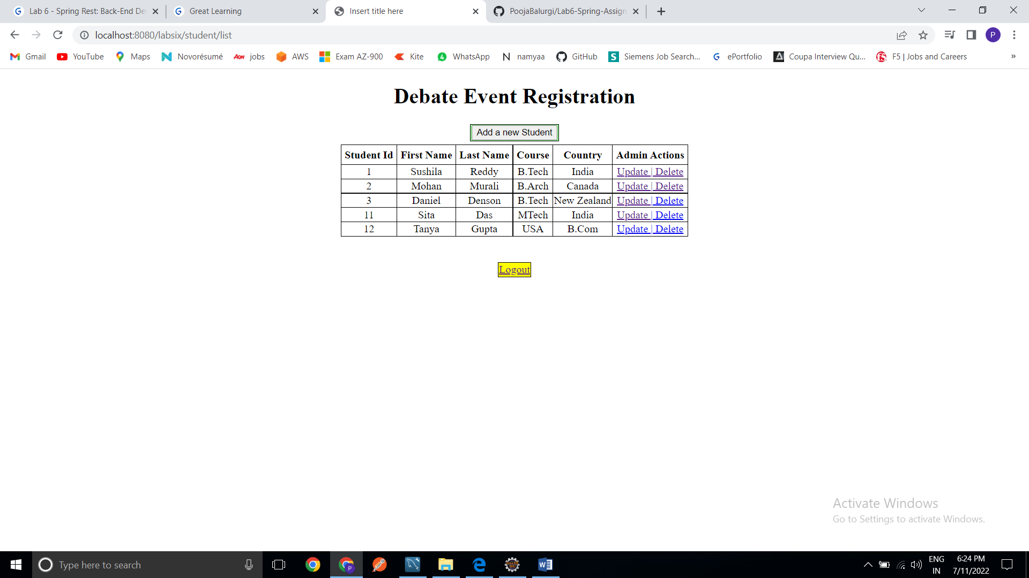

Trying to Update Sita: Giving error

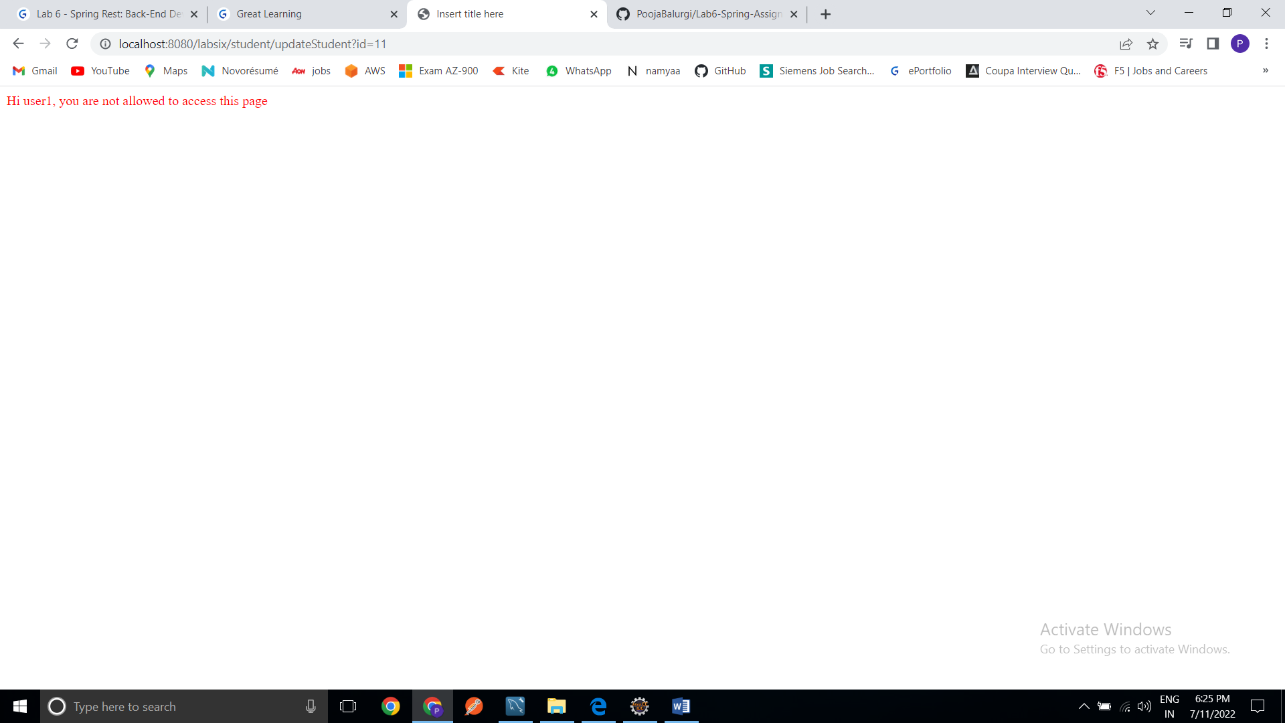

Trying to Delete Sita:

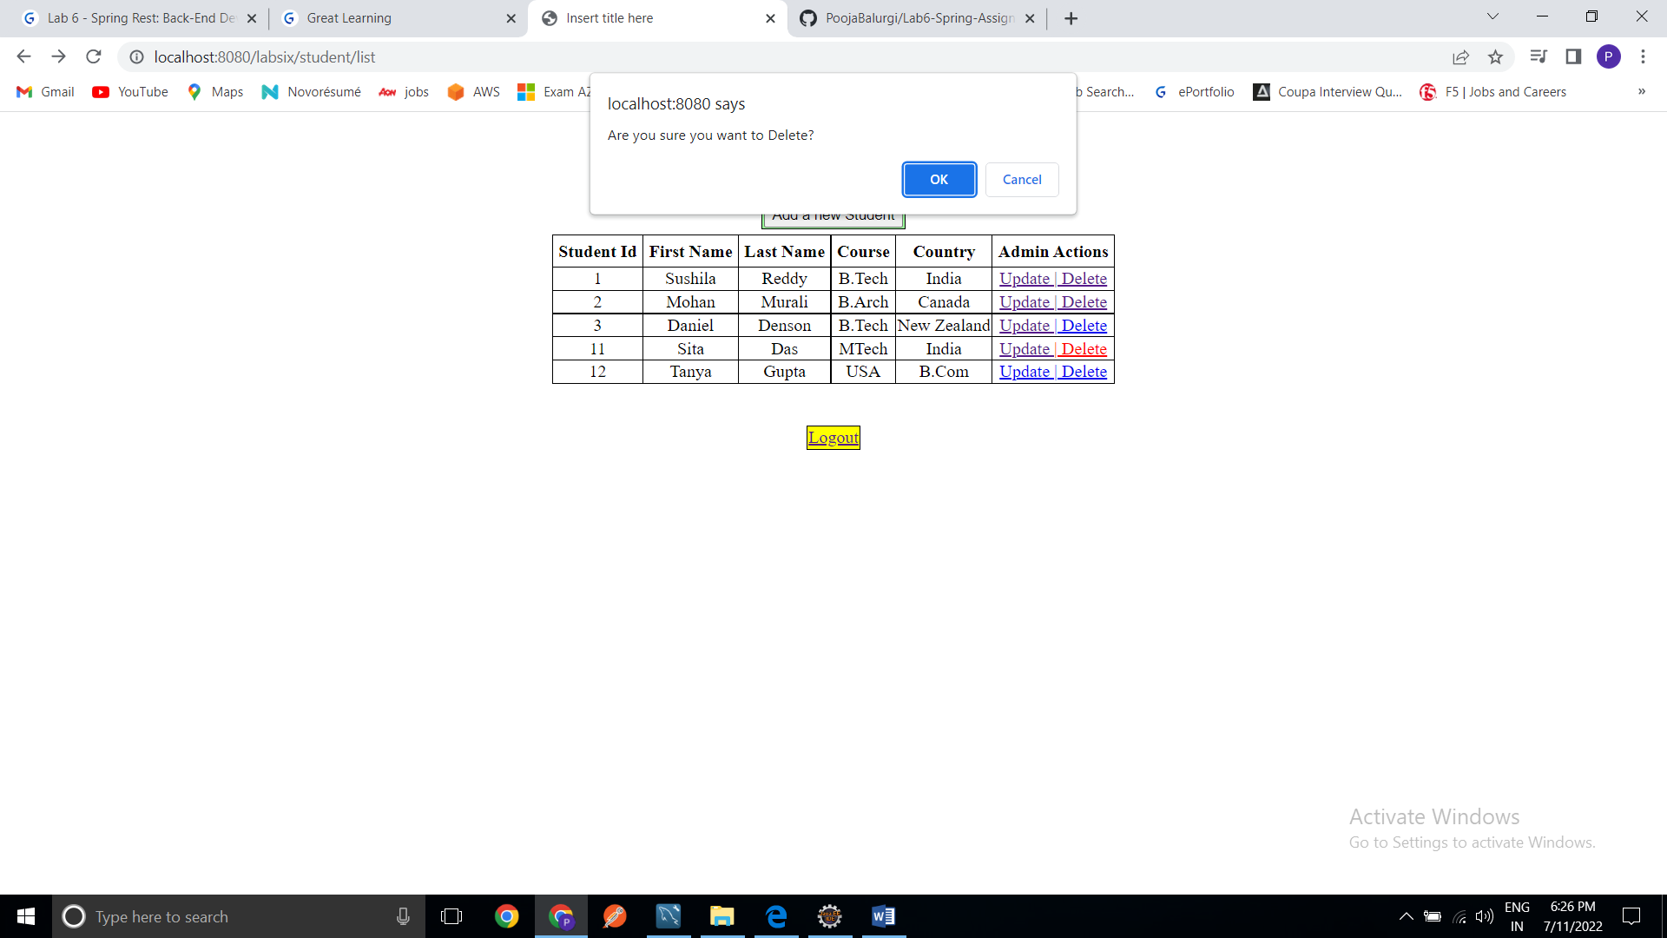

After ok: Giving error

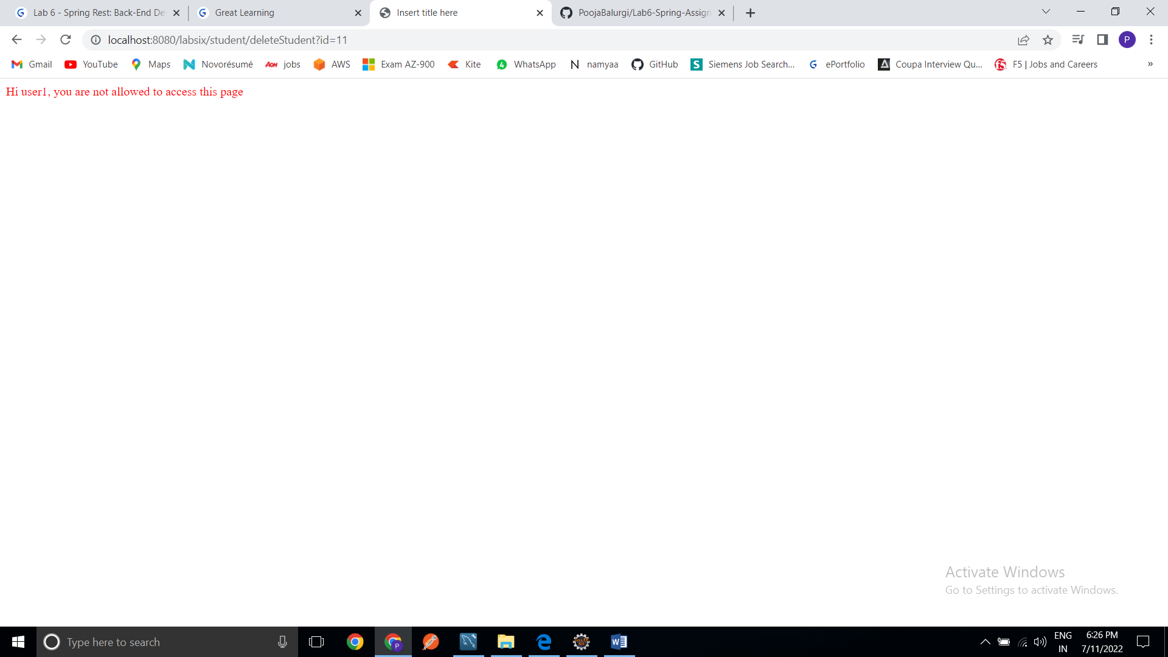

Logout:

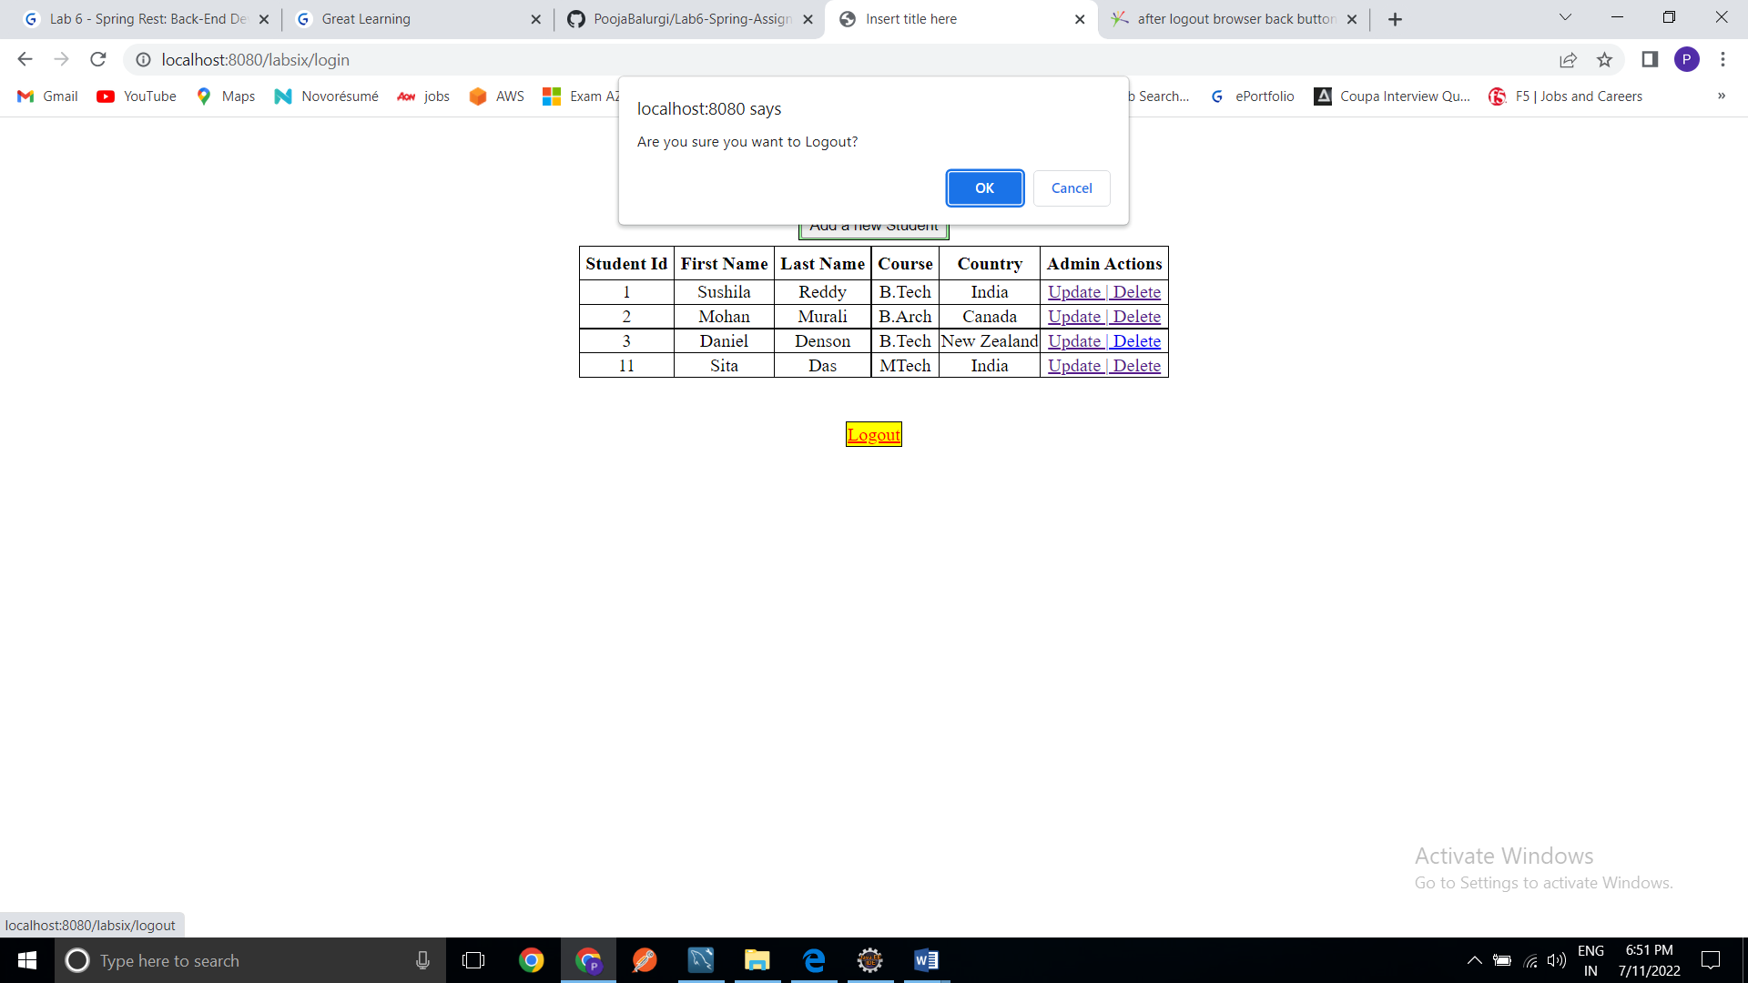

Thank you…!!